Great Course Companions

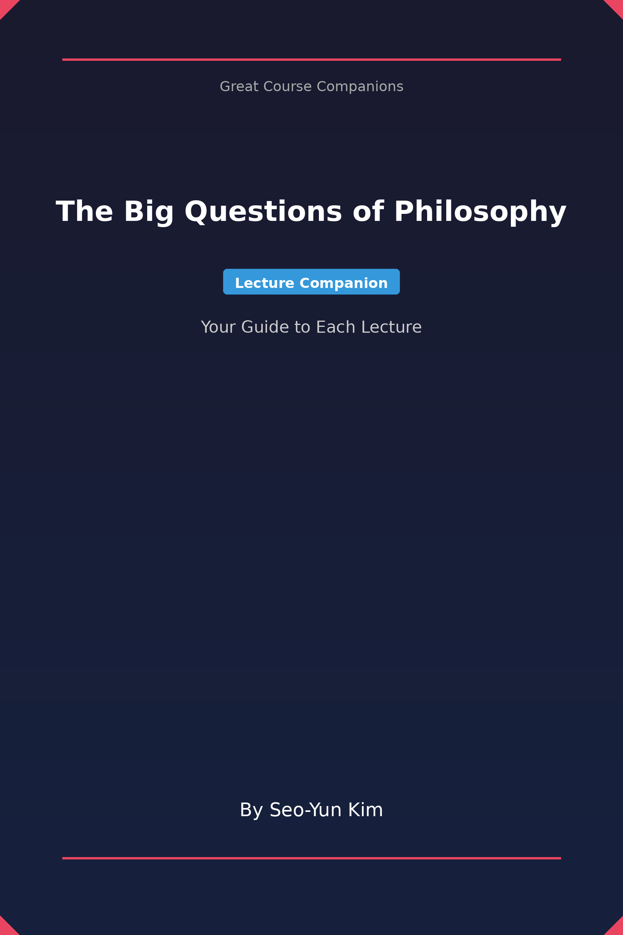

The Big Questions of Philosophy
  - Your Guide to Each Lecture
— Lecture Companion —

By Seo-Yun Kim

Copyright © 2026 Seo-Yun Kim
All rights reserved.
Published by Independent Publishing
First Edition: January 2026
ISBN: [Pending]

IMPORTANT NOTICE
This companion guide is an independent educational resource created to enhance your learning experience. It is not affiliated with, endorsed by, or connected to The Great Courses, The Teaching Company, or any course instructor.
All original content, analysis, discussion questions, and synthesis in this guide are the intellectual property of the author. This guide is intended as a transformative educational work that provides original commentary, analysis, and study materials.
No part of this publication may be reproduced, distributed, or transmitted in any form without prior written permission of the publisher, except for brief quotations in reviews and educational contexts.

Table of Contents
[To generate: In Word, go to References → Table of Contents → Automatic Table 1]

Introduction
Welcome to this companion guide for "The Big Questions of Philosophy."
This guide is designed to enhance your learning experience by providing structured summaries, key concepts, discussion questions, and deeper analysis of the course material. Whether you're reviewing after lectures or preparing for discussions, this companion will help you engage more deeply with the philosophical ideas presented.
Each section includes:
• **Key Points** — The main arguments and ideas from each lecture
• **Core Concepts** — Definitions and explanations of important terms
• **Discussion Questions** — Prompts to stimulate critical thinking
• **Practical Applications** — Ways to apply these ideas to everyday life
Use this guide alongside your course materials to maximize your understanding and retention of these profound philosophical questions.
Happy learning!
Seo-Yun Kim

Lecture 1
Liberty and the Limits of Government: Exploring Mill's Philosophy
In this lecture, we explore the philosophical underpinnings of government intervention and the limits of liberty as articulated by John Stuart Mill. We examine key concepts such as the tyranny of the majority and the harm principle, applying them to contemporary issues like marijuana legalization and freedom of speech.

Key Points
1. The Role of Government
Government is often perceived as a restrictor of actions rather than merely a provider of services. The lecture discusses the various ways governments impose regulations, from laws against murder to restrictions on personal behavior.
2. Tyranny of the Majority
Mill introduces the concept of the 'tyranny of the majority,' where the majority can oppress minority groups without accountability. This highlights the need for safeguards to protect individual rights against collective decision-making.
3. Utilitarianism and Liberty
Mill argues that the protection of liberty is essential for maximizing happiness, suggesting that individuals know their desires better than the government. Thus, personal freedom is tied to societal progress and individual fulfillment.
4. Defining Harm
Mill's harm principle states that the only justification for government intervention in personal actions is to prevent harm to others. This raises important questions about what constitutes 'harm' and how it is legally defined.
5. Limitations of Legal and Moral Standards
Mill distinguishes between legality and morality, arguing that just because an action is legal does not mean it is moral and vice versa. This suggests a complex relationship between law, ethics, and personal freedom.
6. Contemporary Issues
Applying Mill's philosophy to current debates, the lecture discusses the legalization of marijuana, gay marriage, and freedom of speech, arguing that these issues should be assessed through the lens of individual liberty and the harm principle.
7. The Importance of Free Speech
Mill defends the necessity of free speech for societal progress, stating that allowing various opinions, even false ones, fosters a deeper understanding of truth and prevents dogmatism.

Core Concepts
• Tyranny of the Majority: A situation where the majority's interests oppress those of a minority, leading to a loss of individual rights.
• Harm Principle: A principle that states that individuals should be free to act however they want unless their actions cause harm to others.
• Utilitarianism: An ethical theory that suggests the best actions are those that maximize overall happiness or utility.
• Definite Harm: A specific, tangible harm that justifies legal restrictions, as opposed to mere offense or emotional discomfort.
• Conformity and Individuality: The tension between societal norms and individual freedom, where excessive conformity can stifle personal development and societal progress.

Practical Applications
• Understanding Political Rights: These concepts can help students better understand their rights and responsibilities as citizens, especially in democratic societies.
• Analyzing Current Events: The application of Mill's ideas allows for a critical analysis of contemporary debates surrounding personal freedoms and government regulations.
• Ethical Decision-Making: Students can use Mill's utilitarian framework to evaluate ethical dilemmas in personal and professional contexts.

Discussion Questions
1. How does Mill's concept of the tyranny of the majority apply to current social issues?
2. In what ways might the harm principle limit personal freedoms, and do you think it should?
3. Can legality and morality ever be fully aligned, or are they inherently at odds?
4. How do Mill's ideas on free speech challenge current societal norms regarding hate speech?
5. What implications does Mill's philosophy have for the legal status of controversial issues like drug use or marriage?

Further Exploration
• Research the historical context of Mill's work and its impact on modern democratic theory.
• Explore the relationship between utilitarianism and contemporary ethical frameworks.
• Investigate case studies where the harm principle has been applied in legal contexts.

Lecture 2
Justice as Fairness: Exploring Rawls' Theory
This lecture delves into John Rawls' influential concept of a just society, focusing on his principles of justice and their implications for economic inequality. We compare Rawls' ideas with those of his critics, particularly in the context of contemporary social issues.

Key Points
1. The Concept of a Just Society
Rawls argues that a just society is fundamentally a fair society. This notion requires an examination of how resources and opportunities are distributed among individuals, emphasizing fairness as a core value.
2. The Original Position and Veil of Ignorance
Rawls introduces the thought experiment of the 'original position,' where individuals must agree on societal principles without knowing their future status, thus ensuring impartiality. The 'veil of ignorance' safeguards against bias based on personal circumstances.
3. Principle of Justice Number One
The first principle asserts that every individual should have equal rights to the most extensive basic liberties compatible with similar liberties for others. This aligns with Mill's harm principle but expands it to encompass broader liberties.
4. Principle of Justice Number Two
The second principle acknowledges that inequalities are acceptable only if they benefit everyone, particularly the least advantaged. This principle promotes social mobility and aims for a fair distribution of economic resources.
5. Rawls vs. Supply Side Economics
While Rawls allows for some income inequality, he critiques supply-side economics, arguing that wealth does not naturally trickle down. Instead, he advocates for government intervention to manage inequalities that arise in a free market.
6. Practical Implications of Rawls' Theory
Rawls' ideas suggest that policies should be designed to provide opportunities for the less fortunate, such as education and welfare programs, rather than merely redistributing wealth. This approach promotes a healthier and more equitable society.
7. Critique of Current Economic Systems
The lecture discusses how many modern societies, including the U.S., fail to meet Rawlsian ideals. Issues like insufficient minimum wage and political influence by the wealthy highlight systemic inequalities that contradict the principles of justice.

Core Concepts
• Justice as Fairness: Rawls' theory that a just society is one that prioritizes fairness in the distribution of rights, opportunities, and resources.
• Veil of Ignorance: A hypothetical scenario where individuals design societal rules without knowledge of their own future social position, ensuring fairness.
• Original Position: The theoretical starting point for individuals to agree on principles of justice, free from personal biases.
• Basic Liberties: Fundamental rights that every individual should possess, including freedom of speech, religion, and personal autonomy.
• Economic Inequality: The disparity in wealth and resources among individuals in a society, which Rawls argues should be arranged to benefit the least advantaged.

Practical Applications
• Understanding Social Policies:
• Developing Ethical Frameworks:
• Engaging in Civic Discourse:

Discussion Questions
1. How might Rawls’ principles of justice influence contemporary debates on income inequality?
2. What are the potential challenges in applying Rawls' theory to real-world policies?
3. In what ways does the concept of the 'veil of ignorance' help us understand our biases in societal issues?
4. Can a society ever achieve complete fairness, or is some level of inequality inevitable?
5. How do Rawls' ideas compare with other theories of justice, such as utilitarianism or libertarianism?

Further Exploration
• Explore the criticisms of Rawls' theory, particularly from libertarian perspectives.
• Investigate real-world examples of policies inspired by Rawlsian principles.
• Read Rawls' 'A Theory of Justice' for a deeper understanding of his arguments and thought experiments.

Lecture 3
The Search for Meaning in Life
This lecture explores the philosophical question of life's meaning and whether existence can hold significance in a universe that may seem indifferent. Through the lens of Douglas Adams' 'The Hitchhiker's Guide to the Galaxy,' we delve into themes of personal identity, purpose, and the nature of existence.

Key Points
1. Philosophical Reflection on Existence
Drawing parallels between Arthur's journey in 'The Hitchhiker's Guide to the Galaxy' and human existence, this point emphasizes how both are marked by randomness and the inevitability of death. Just like the whale's pondering, we too are faced with questions about our purpose and identity.
2. The Meaning of Life Question
The lecture poses the fundamental question: 'What is the meaning of life?' It challenges students to consider whether this inquiry is about human existence as a whole or individual life experiences, and whether we can even define what it means for life to be meaningful.
3. Purpose vs. Meaning
The distinction between purpose and meaning is crucial. A life can have purpose (e.g., a role assigned by a deity) without being meaningful. This point critiques the notion that divine purpose automatically translates to a meaningful existence.
4. Significance and Its Role
Significance often relates to the impact one has on the world. However, the lecture argues that significance does not equate to meaning, as evidenced by the example of achievements that lack moral or existential weight.
5. Subjective Meaning vs. Objective Meaning
The idea that meaning can be subjective suggests that individuals can derive meaning from their personal experiences, goals, and relationships, contrasting with the search for an objective meaning determined by external standards.
6. The Absurdity of Life
Referencing Albert Camus, this point discusses the notion of life's absurdity and how one can find joy in existence despite its inherent meaninglessness, using the metaphor of Sisyphus to illustrate resilience in the face of futility.
7. The Role of Free Will
The lecture examines the implications of free will on the search for meaning. If our choices are predetermined or influenced by external factors, it raises questions about the authenticity of our pursuits and their significance.

Core Concepts
• Personal Identity: The philosophical inquiry into what it means to be a person, including questions of consciousness, self-awareness, and the essence of individuality.
• Existentialism: A philosophical movement that emphasizes individual existence, freedom, and choice, positing that individuals are responsible for creating their own meaning in a seemingly indifferent universe.
• Absurdism: The belief that human beings exist in a purposeless, chaotic universe and that the search for meaning is inherently in conflict with this absurdity.
• Subjective Meaning: The idea that meaning is derived from personal experiences and perceptions rather than being universally or objectively defined.

Practical Applications
• Understanding Existential Questions: Applying the philosophical inquiries from this lecture can help individuals navigate personal crises or existential doubts, leading to deeper self-reflection and understanding.
• Finding Personal Purpose: Students can use insights from this lecture to explore their own values and goals, helping them to create a sense of meaning in their lives based on personal aspirations.
• Engagement with Philosophy: The concepts discussed encourage students to engage with philosophical texts and ideas, fostering critical thinking and analytical skills applicable in various fields of study.

Discussion Questions
1. What implications does the idea of randomness in existence have on our understanding of personal identity?
2. Can life hold meaning without an objective purpose? How might this change our approach to daily actions?
3. In what ways can we create subjective meaning in our lives despite the absurdity of existence?
4. How does the critique of purpose inform our understanding of fulfillment and satisfaction in life?
5. What role does free will play in the search for meaning, and can we truly be 'free' in our choices?

Further Exploration
• Consider reading Albert Camus' 'The Myth of Sisyphus' for a deeper understanding of absurdism.
• Explore existentialist philosophers like Jean-Paul Sartre and their views on freedom and meaning.
• Investigate the role of narrative and storytelling in constructing personal meaning, as seen in literature and art.

About the Author
Seo-Yun Kim is an independent educational writer and course companion author specializing in making complex academic content accessible to lifelong learners.
With a passion for philosophy, science, and the humanities, Seo-Yun creates study guides that help students and curious minds engage more deeply with great courses and lectures from top professors.
The Great Course Companions series provides thoughtful analysis, discussion questions, and synthesis to transform passive viewing into active learning.
Connect with the author:
• Email: [contact email]
• Website: [website]
Other titles in the Great Course Companions series:
[More titles coming soon]

